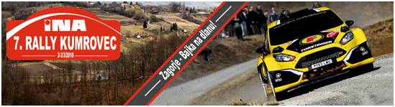

ACCREDITATION FORM FOR JOURNALIST
Name and Surname:
 | Editorial office:
 | Mark with X |  | Newspaper
 | Mark with X |  | Radio
 | Mark with X |  | Internet
 | Mark with X |  | TV
 | Mark with X |  | Journalist
 | Mark with X |  | Photoreporter
 | Mark with X |  | Cameraman
 | Contact address:
 | Phone / Mobile:
 | Fax:
 | E-mail:
 | Web site:

RALLY HQ, AUTOMOBILE CLUB ”DELTA SPORT” ZAGREB
HQ: Nalješkovićeva 27, HR-10000 Zagreb
Mob: +385 98 460 082
Web address: www.rally-kumrovec.com
E-mail: info@deltasport.hr

RALLY PRESS CENTER
2. March 2018 from 12:00 till 15:00 hours, MUNCIPALITY KUMROVEC, Ulica Josipa Broza 12, HR-49295 Kumrovec
2. March 2018 from 15:30 till 21:30 hours, TERME TUHELJ, Ljudevita Gaja 4, HR-49215 Tuheljske Toplice
3. March 2018 from 08:00 till 21:00 hours, MUNCIPALITY KUMROVEC, Ulica Josipa Broza 12, HR-49295 Kumrovec
Contact person: Boris Jelavić, Press relation officer
E-mail: press@rally-kumrovec.com
Mob:: +385 91 572 83 50

Advance payment for press marker in the amount of 100,00 HRK / 15,00 EUR.

Place and date: |  | Signature:

By signing this form, I agree to participate in the competition on my own risk!

